**VISVESVARAYA TECHNOLOGICAL UNIVERSITY**

Jnanasangama, Macche, Santibastwada Road

Belagavi - 590018, Karnataka



**A**

**II Sem BE MINI-project (22IDT28) REPORT**

on

**Landslide Detection System using Arduino with metal strip accelerometer and soil moisture sensing**

*Submitted in partial fulfillment of the requirement for the degree of*

**Bachelor of Engineering**

*in*

**Electronics & Communications Engineering - ECE**

*by*

**USN : 1DS22EC054 Chaitra Krishna Gouda**

**USN : 1DS22EC076 Gowri Bharadwaj HP**

**USN : 1DS22EC138 Nagalakshmi S**

**USN : 1DS22EC181 S Swetha Vaisshnavi**

Under the guidance

of

**Dr Basavaraj S K**

Designation

ECE Dept., DSCE, Bengaluru



**Department of Electronics & Communication Engineering**

(An Autonomous College affiliated to VTU Belgaum, accredited by NBA & NAAC)

Shavige Malleshwara Hills, Kumaraswamy Layout, Bengaluru-560078, Karnataka, India

**Certificate**

Certified that the mini-project work **(Course Code : 22IDT28)** entitled “**Landslide Detection System by metal strip accelerometer and soil moisture sensing**” carried out by **Chaitra Krishna Gouda**(1DS22EC054), **Gowri Bharadwaj HP**(1DS22EC176), **Nagalakshmi S**(1DS22EC138) and S Swetha Vaisshnavi(1DS22EC181) are bonafide students of the ECE Dept. of Dayananda Sagar College of Engineering, Bangalore, Karnataka, India in partial fulfillment for the award of Bachelor of Engineering in Electronics & Communication Engineering of the Visvesvaraya Technological University, Belagavi, Karnataka for the **II Semester course** during the academic year 2022-23. It is certified that all corrections / suggestions indicated for the mini-project work have been incorporated in the mini-report submitted to the ECE department. This **2nd semester mini-project report** has been approved as it satisfies the academic requirement in respect of mini-project work prescribed for the said degree.

Mini-Project Guide Sign : _______________________________________________________

Name : **Dr Basavaraj S K**

Mini-Project Section Coordinator Sign : __________________________________________

Name : **Dr Sindhusree M**

Mini-Project Convener & Chief Coordinator Sign : _________________________________

Name : **Dr. Pavithra G., Assoc. Prof., ECE, DSCE**

**Dr. T.C. Manjunath : __________________________________________________________**

Prof. & HOD, ECE, DSCE

**Dr. B.G. Prasad** : ____________________________________________________________

Principal, DSCE

External Mini-Project Viva-Voce (SEE)

Name of the mini-project examiners (int & ext) with date :

1 : Signature : _____________________

2 : Signature : _____________________

# Declaration

Certified that the mini-project work entitled, **“Landslide Detection using Arduino with Metal Strip accelerometer and soil moisture sensing”** with the course code **22IDT28** (2 Credits, 100 Marks, CIE & SEE 50 marks each) is a bonafide work that was carried out by ourselves in partial fulfillment for the award of degree of Bachelor of Engineering in Electronics & Communication Engg. of the Visvesvaraya Technological University, Belagavi, Karnataka during the academic year 2022-23 for the II Semester Autonomous Course. We, the students of the 2nd sem mini-project group/batch no. P-03 do hereby declare that the entire mini-project has been done on our own & we have not copied or duplicated any other’s work. The results embedded in this mini-project report has not been submitted elsewhere for the award of any type of degree.

Student Name-1 :Chaitra Krishna Gouda USN : 1DS22EC054

Sign : _____________________

Student Name-2 : Gowri Bharadwaj H P USN : 1DS22EC076

Sign : _____________________

Student Name-3 : Nagalakshmi S USN : 1DS22EC138

Sign : _____________________

Student Name-4 : S Swetha Vaisshnavi

USN : 1DS22EC181

Sign : _____________________

Date : 09 /09/2023 Place : Bengaluru -111

# Acknowledgement

In this section, a brief acknowledgment has to be presented as a thanks giving to all the people who have directly or indirectly helped in the successful completion of the undergraduate mini-project work.

Thanks giving hierarchy to the members in this order :

1. Chairman – Dr. Hemachandra Sagar
2. Vice Chairman – Dr. Premachandra Sagar
3. Secretary – Galiswamy
4. Joint Secretary – Tintisha Sagar
5. Principal – Dr. B.G. Prasad
6. HOD – Dr. T.C. Manjunath
7. Mini Project Guide – Dr Basavaraj S K
8. Mini-Project Section-wise Coordinators– Dr Sindhusree M
9. Mini-Project Convener & Chief Coordinator – Dr. Pavithra G.
10. Dept. staff members – Teaching & Non-teaching
11. Family members & relatives
12. Friends
13. Almighty

**Abstract**

This study presents the development and implementation of an innovative *landslide detection* system employing a combination of *Arduino microcontroller*, metal strip accelerometer, and *soil moisture sensing* technologies. Landslides are natural disasters with devastating consequences, necessitating reliable early warning systems for mitigation efforts. The proposed system addresses this need by utilizing a metal strip accelerometer to detect ground movement and a soil moisture sensor to monitor changes in soil stability. The *metal strip accelerometer* provides real-time data on ground acceleration, enabling the system to identify potential landslide events. Additionally, the soil moisture sensor measures variations in soil moisture content, a critical factor in landslide susceptibility. The Arduino microcontroller processes and analyzes the sensor data, triggering an alert mechanism in the event of abnormal readings indicative of landslide risk. The system's integration of these diverse sensors enables comprehensive and accurate landslide detection, offering a cost-effective and scalable solution for vulnerable regions prone to landslides. The results of field tests demonstrate the system's efficacy in detecting subtle ground movements and changes in soil conditions, providing timely warnings to potentially affected communities. Furthermore, the low-power consumption and compact form factor of the Arduino-based system enhance its suitability for remote and resource-constrained areas. This research contributes to the advancement of landslide *early warning systems*, offering a valuable tool for disaster preparedness and risk reduction strategies.

**Table of Contents**

Title Sheet i

Certificate ii

Declaration iii

Acknowledgement iv

Abstract v

Table of Contents vi

List of Figures vii

Chapter 1 Introduction 1

Chapter 2 Literature survey 2

Chapter 3 Problem Statement & objectives 3

Chapter 4 Methodology, Block diagram & Implementation 4

Chapter 5 Hardware /software tools used 5

Chapter 6 Photographs of the model/Simulation Results 6

Chapter 7 Results and Discussions 7

Chapter 8 Applications ,Advantages , Outcomes & Limitations 8

Chapter 9 Conclusion & Future work 9

References 10

Appendix 11

Paper presented / Publications during tenure of Mini-Project Work 12

Awards and Recognitions 13

Photographs 14

Instructions to the students 15

# List of Figures

Fig. 1: Landslide 1

Fig. 2 : Block Diagram of interfacing Soil moisture with Arduino 2

Fig. 3 : circuit diagram of metal strip accelerometer 3

Fig. 4 : Flow chart of the overall model 4

# Introduction

Landslides are natural disasters that have the potential to cause significant damage to human lives, infrastructure, and the environment. The sudden and often unpredictable nature of landslides necessitates the development of effective detection and monitoring systems to mitigate their adverse impacts. In response to this pressing need, this project endeavors to create a novel landslide detection solution by employing Arduino microcontrollers equipped with metal strip accelerometers. The proposed system aims to provide an economical, adaptable, and accessible means of identifying ground movements that might signify an impending landslide event. This report presents an in-depth overview of the objectives, methodology, expected outcomes, and the overarching significance of the project.

**Overview:**

Landslides, triggered by a variety of factors including heavy rainfall, seismic activities, and human interventions, are a recurrent hazard that challenges the safety of communities worldwide. The aftermath of landslides often includes destruction of homes, disruption of transportation networks, and ecological imbalance. Consequently, the development of early warning systems that can promptly detect and alert authorities and residents about potential landslide events holds immense importance. The primary objective of this project is to design and implement a cost-effective and efficient landslide detection system utilizing Arduino microcontrollers integrated with metal strip accelerometers. This system aims to detect subtle ground movements that may indicate the onset of a landslide, thus enabling timely response and evacuation measures. By leveraging the capabilities of Arduino technology and the precision of metal strip accelerometers, the project strives to create a solution that can be readily deployed even in resource-constrained areas. The methodology involves the deployment of metal strip accelerometers in strategic locations to monitor ground displacement. These accelerometers will be interfaced with Arduino microcontrollers programmed to analyze the sensor data. The microcontrollers will compute the rate of displacement changes and trigger alerts if the recorded values surpass predefined thresholds. This early warning mechanism will serve as a pivotal tool in minimizing the potential impacts of landslides. Anticipated outcomes encompass the creation of a functional prototype of the landslide detection system, demonstrating its feasibility and efficacy. Additionally, the project aims to establish a reliable early warning mechanism capable of swiftly notifying relevant authorities and communities about potential landslide risks. Moreover, the data accumulated from the system's operation will facilitate the analysis of ground movement patterns, refining the detection algorithm for enhanced accuracy. The significance of this project lies in its potential to revolutionize landslide detection technology. By employing affordable components such as Arduino microcontrollers and metal strip accelerometers, the system addresses the limitations of traditional monitoring methods that are often expensive and technologically intricate. This approach democratizes the ability to detect and respond to landslide threats, making it accessible to communities that are particularly vulnerable to such natural disasters. In conclusion, this project introduces an innovative solution for landslide detection through the utilization of Arduino microcontrollers integrated with metal strip accelerometers. The pursuit of this endeavor is fueled by the urgency to enhance early warning capabilities, minimize risks, and maximize preparedness in the face of potential landslide events. Through its objectives, methodology, anticipated outcomes, and broader significance, the project exemplifies a commitment to advancing safety and disaster resilience in landslide-prone regions.

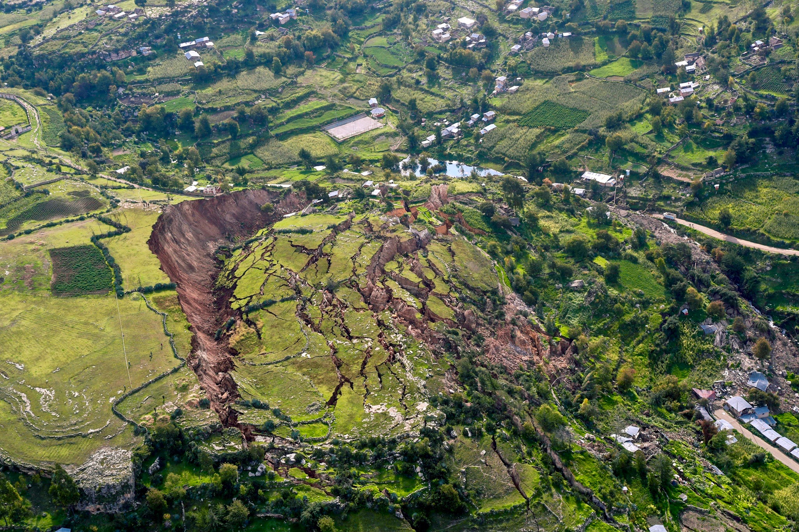

**Literature survey:**

In recent years, the field of landslide detection has witnessed significant advancements, incorporating various technologies to enhance the accuracy and efficiency of early warning systems. A comprehensive literature survey highlights several notable studies that have explored different approaches to landslide detection, each with its set of advantages and disadvantages.

**Authors and Approaches:**

One seminal work in this domain is the research conducted by Ms. N. C. Kalaskar (2016) - under the title “Landslide Warning System using AVR micro controller, IRJET.” The system shown in this paper uses different types of sensors like rain, soil moisture, accelerometer etc. for detection.

Similarly, Maneesha Vinodini Ramesh (2017) published a paper under the title ”Wireless Sensor Networks for Early Warning of Landslides: Experiences from a Decade Long Deployment.” This paper works on the real time incidents that took place in different parts of India thereby by implementing it through a wireless probe network.

Another noteworthy paper by Prapti Giri (2018) titled Wireless Sensor Network System for Landslide Monitoring and Warning. It was based on wireless sensor network system or effective, reliable, and efficient monitoring of landslides.

Additionally, Chenhui Wang (2022) published a paper titled “Real-Time Monitoring System of Landslide Based on LoRa Architecture”. It was based on the Overall node system design, using long range(LoRa) and IOT, Software Design of Landslide Monitoring System and Result analysis.

**Objectives of the mini-project work**

* Acknowledgement of the Problem of Landslide and planning a cost effective detection system.
* Planning and Construction of a Simple Circuit using Metal strips which functions as an accelerometer.
* Interfacing of Soil Moisture Sensor and I2C LCD display with the Arduino.
* Final Implementation by merging of both the above functions and Demonstration.

**Problem Statement**

Landslides pose a significant threat to communities residing in regions characterized by unstable terrain and adverse geological conditions. The destructive potential of landslides necessitates the development of effective early warning systems to mitigate potential disasters. Current landslide detection methodologies often suffer from limitations in cost, accessibility, and accuracy, hindering their widespread implementation in vulnerable areas.

The existing solutions primarily rely on expensive and complex monitoring equipment, making them impractical for deployment in resource-constrained regions. Additionally, these systems may not provide real-time or continuous monitoring, potentially leading to delayed warnings. Furthermore, some conventional methods do not adequately consider the dynamic interplay between ground movement and soil stability, leading to false alarms or missed alerts.

This research addresses these critical shortcomings by proposing an integrated Landslide Detection System utilizing readily available components such as an Arduino microcontroller, a metal strip accelerometer, and a soil moisture sensor. By harnessing the capabilities of these technologies, this system aims to offer a cost-effective, accessible, and accurate solution for landslide detection.

The metal strip accelerometer serves as the primary ground movement sensor, capable of detecting even subtle shifts in terrain stability. Simultaneously, the soil moisture sensor provides valuable insights into the moisture content of the soil, a pivotal factor in landslide susceptibility. Through the integration and intelligent processing of data from these sensors, the system intends to provide timely and accurate warnings of impending landslide events.

**Proposed Solution:**

The project seeks to address some of the limitations present in existing methods while capitalizing on their strengths. By utilizing Arduino microcontrollers with metal strip accelerometers, the proposed solution aims to provide an affordable, adaptable, and reliable landslide detection system.

The use of Arduino microcontrollers ensures cost-effectiveness and accessibility, making the system deployable even in resource-constrained regions. Metal strip accelerometers, which are sensitive to ground movements, serve as efficient detectors for subtle shifts in soil that might precede landslides. This approach avoids the complexities associated with satellite imagery and the limitations of expensive sensor technologies.

The project's methodology involves the strategic placement of metal strip accelerometers in areas prone to landslides. These accelerometers will be interfaced with Arduino microcontrollers, which will process the collected data. The microcontrollers will calculate the rate of displacement changes and trigger alerts if predefined thresholds are exceeded. This real-time monitoring and early warning mechanism intend to minimize response time and reduce the potential impacts of landslides.

In conclusion, the literature survey underscores the diverse landscape of landslide detection techniques, each offering unique advantages and disadvantages. The proposed solution, through its utilization of Arduino microcontrollers and metal strip accelerometers, aims to overcome the drawbacks of existing methods and provide an effective, accessible, and affordable approach to landslide detection. By doing so, the project contributes to enhancing safety and preparedness in landslide-prone areas.

**Methodology:**

**1. *Sensor Selection and Calibration*:**

- Select appropriate metal strip accelerometer and soil moisture sensor based on their sensitivity, accuracy, and compatibility with the Arduino microcontroller.

- Calibrate the sensors to ensure accurate readings. This involves setting baseline values for both the accelerometer (zero-point calibration) and soil moisture sensor (dry and wet calibration).

**2. *Hardware Setup\***

- Connect the metal strip accelerometer and soil moisture sensor to the Arduino microcontroller using suitable wiring and connectors.

- Ensure proper power supply and grounding for all components to prevent interference and ensure reliable operation.

**3. *Data Acquisition and Processing*:**

- Program the Arduino microcontroller to read data from the sensors at regular intervals.

- Apply appropriate filtering techniques to remove noise from sensor readings.

- Store and timestamp the acquired data for later analysis.

**4. *Ground Movement Detection*:**

- Implement algorithms to process data from the metal strip accelerometer for ground movement analysis.

- Define thresholds for acceleration values that may indicate potential landslide conditions.

- Identify patterns or anomalies in the accelerometer data indicative of ground movement.

**5. *Soil Moisture Analysis*:**

- Develop algorithms to interpret data from the soil moisture sensor.

- Set thresholds for moisture content levels that may indicate increased landslide susceptibility.

- Monitor changes in soil moisture content over time to assess stability.

**6. *Integration and Decision Making*:**

- Combine the outputs of the metal strip accelerometer and soil moisture sensor to make informed decisions.

- Implement logic to trigger alerts in the event of abnormal sensor readings or conditions suggestive of potential landslides.

**7. *Alert Mechanism*:**

- Integrate an alert system to notify relevant authorities or communities in the event of potential landslide risks.

- Utilize visual indicators, sound alarms for timely dissemination of warnings.

**8. *Optimization and Fine-Tuning*:**

- Analyze the data collected during field testing to identify areas for improvement.

- Adjust sensor thresholds, calibration settings, or algorithms as needed to enhance system accuracy and reliability.

**9. *Documentation and Reporting*:**

- Document the entire methodology, including sensor specifications, hardware setup, programming code, and data analysis procedures.

- Compile the results of field testing, including any challenges encountered and lessons learned.

# 

**Implementation:**

# The implementation of the Landslide Detection System involved a structured series of steps to integrate the Arduino microcontroller with the metal strip accelerometer and soil moisture sensor for effective landslide detection.

# Firstly, the hardware was configured by establishing connections between the metal strip accelerometer, soil moisture sensor, and the Arduino microcontroller. This was followed by ensuring a stable power supply and appropriate grounding to guarantee reliable operation.

# Next, the sensors underwent a calibration process. The metal strip accelerometer was calibrated to set a zero-point reference, while the soil moisture sensor was calibrated in both dry and wet conditions to establish accurate moisture content measurements.

# With the hardware in place and calibrated, data acquisition was initiated. The Arduino microcontroller was programmed to collect data from the sensors at regular intervals. Sampling rates were optimized to balance accurate readings with minimal power consumption.

# Ground movement detection was a critical aspect of the implementation.

Finally, the implementation process was thoroughly documented. This encompassed detailed records of hardware setup, programming code, and data analysis procedures. Results were compiled, including performance metrics, challenges faced, and valuable insights gained during the implementation phase.

**Block Diagram:**

Figure 1:

For Interface of Soil Moisture sensor with Arduino UNO

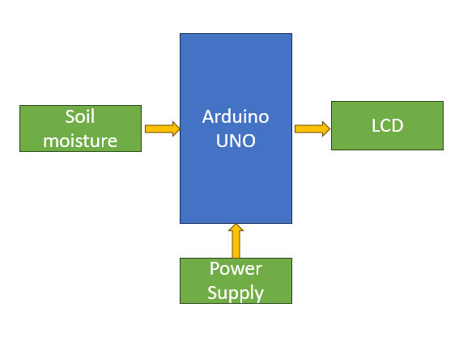

Figure 2: Metal strip accelerometer circuit:

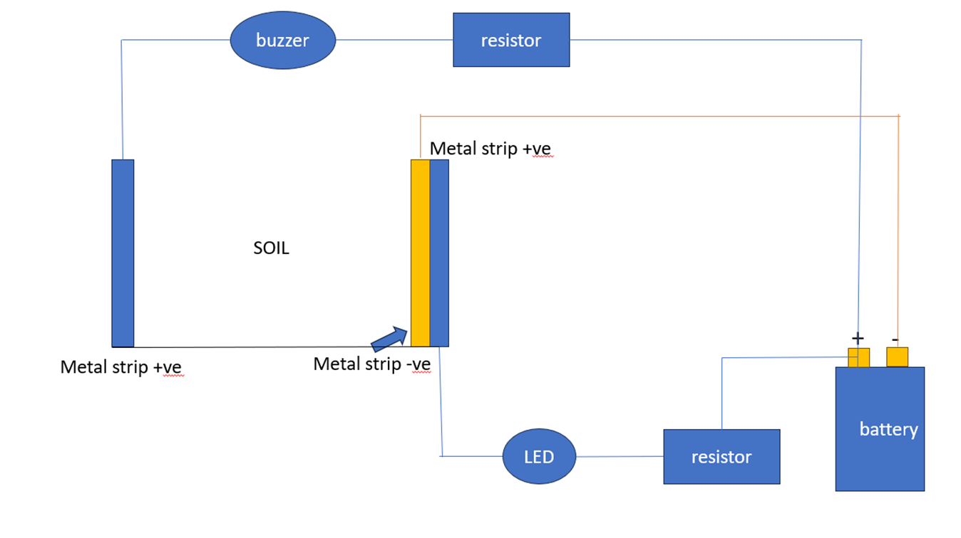

**Working Principle :**

The overall working principle of the mini-project work:

The landslide detection system operates on the principle of monitoring key environmental indicators using specialized sensors integrated with an Arduino microcontroller.

Using Metal strip accelerometer:

During the conditions of a landslide especially in hilly areas, when there is a slight movement in soil the led goes off and when there is considerable sliding of soil, the buzzer goes on. Simultaneously, a soil moisture sensor is utilized to assess the moisture content within the soil. This is a crucial parameter, as excessive moisture can significantly weaken the structural integrity of the soil, increasing the risk of landslides.

The Arduino acts as the central processing unit, responsible for collecting and analyzing data from both the accelerometer and soil moisture sensor. It's programmed to read this data at regular intervals.

The system is set with predefined threshold values for the sensor.

When such a situation is identified, the system triggers an alert. This alert can be conveyed through various means, such as sounding an alarm, illuminating an LED indicator, or sending a notification to a connected device.

During deployment, careful positioning of the sensors and secure connections are essential. Additionally, the system may require calibration to fine-tune the threshold values based on the specific environmental conditions of the deployment site.

This system provides early warnings of potential landslides. This capability is particularly valuable in regions prone to landslides, where early detection can be a critical factor in averting disasters and protecting lives and property.

**Flow Chart for the project:**

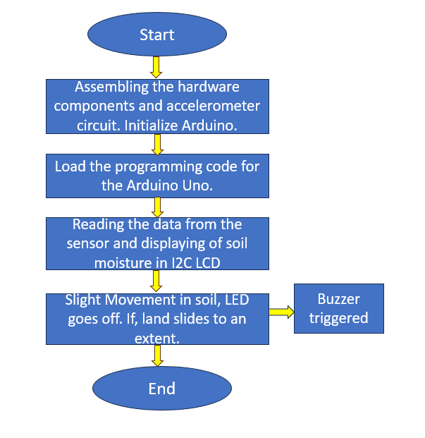

**Hardware / Software tools Used:**

**Hardware :**

The hardware that is used for the mini-project work is:

**-Arduino:**

Arduino UNO is a low-cost, flexible, and easy-to-use programmable open-source microcontroller board that can be integrated into a variety of electronic projects.

**-Resistive Soil Moisture Sensor:**

A resistive soil moisture sensor works by using the relationship between electrical resistance and water content to gauge the moisture levels of the soil. You'll observe these sensors to possess two exposed probes that are inserted directly into the soil sample.

**-LCD i2C display:**

The I2C display interface is a common communication protocol for character, graphic, and segment LCDs. An I2C display consists of an LCD controller and a display module. The interface is communicated over two wires which include a data line and a clock line.

**-Buzzer**

**-LED lights**

**-Metal strips**

**-Battery(9V)**

**Software :**

The software tool used for the mini-project work is (list out the relevant ones used)

Arduino IDE:

The Arduino Integrated Development Environment - or Arduino Software (IDE) - connects to the Arduino boards to upload programs and communicate with them. Programs written using Arduino Software (IDE) are called sketches. These sketches are written in the text editor and are saved with the file extension .

We used Arduino IDE for coding for the soil moisture for displaying soil moisture percentage in the LCD display.

**Photographs of the model:**

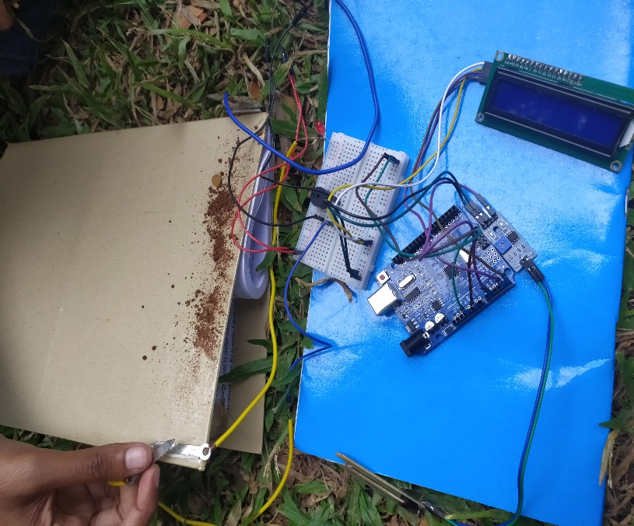

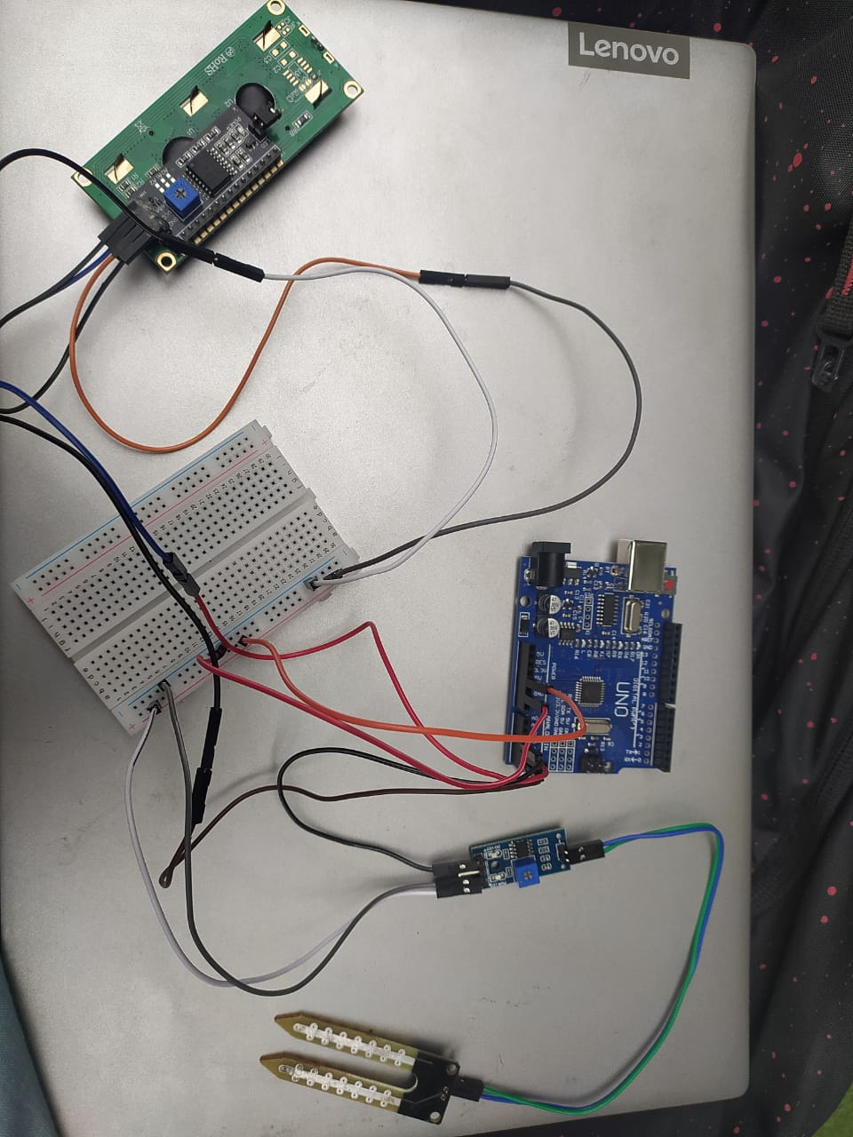

**Results/Outcome:**

During the conditions of a landslide especially in hilly areas, when there is a slight movement in soil the led goes off and when there is considerable sliding of soil, the buzzer goes on.

The interfaced soil moisture sensor shows the moisture percentage and threshold for landslide being 50 percent.

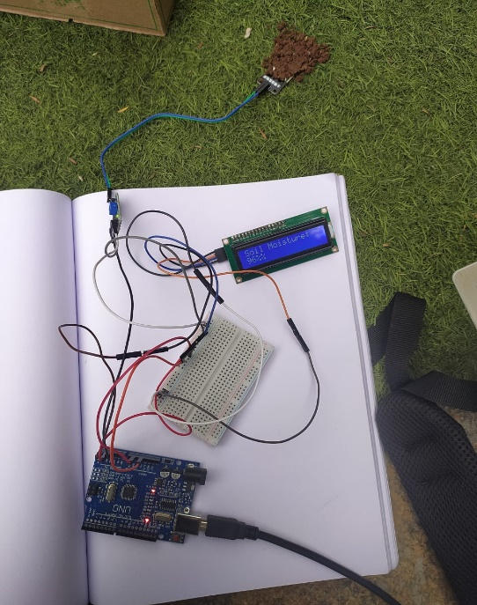 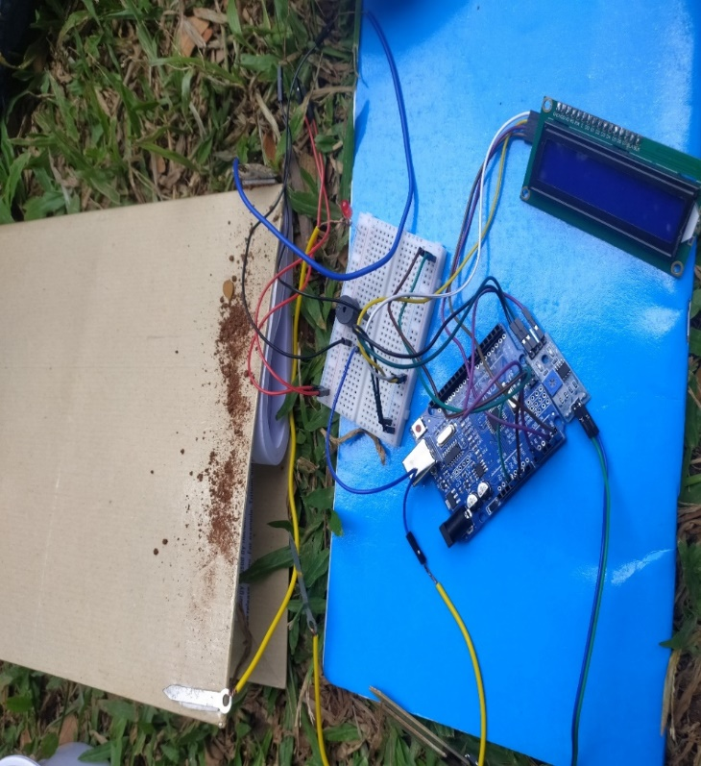

- Soil moisture sensor effectively monitors changes in soil moisture content.

- Integrated system successfully identifies potential landslide risks and triggers timely alerts.

**Advantages:**

Landslide detection systems employing an Arduino, metal strip accelerometer, and soil moisture sensor offer several significant advantages.

**1. *Early Warning System*:**

A primary advantage of this system is its ability to provide early warnings of potential landslides. By monitoring critical environmental indicators, it can detect unstable conditions before they escalate into a full-scale landslide.

**2. *Cost-Effectiveness*:**

This system can be implemented at relatively low costs compared to more complex and specialized landslide detection technologies. The affordability of Arduino microcontrollers and the sensors makes it accessible for deployment in various settings.

**3. *Customizability*:**

The Arduino platform is highly versatile and customizable. This allows for tailoring the system to specific environmental conditions and geographic locations. Threshold values, reporting mechanisms, and alert systems can all be adjusted to suit the needs of the deployment site.

**4. *Integration with IoT and Data Logging*:**

The Arduino can be integrated with the Internet of Things (IoT) networks, enabling remote monitoring and data logging. This is particularly advantageous for regions where physical access is challenging.

**5. *Low Power Consumption*:**

Arduino microcontrollers are known for their low power consumption. When combined with efficient power management techniques, the system can operate for extended periods without frequent maintenance or recharging.

**Disadvantages:**

While the system offers numerous advantages, there are some limitations and potential drawbacks to consider.

**1. *Limited Range and Coverage*:**

The effectiveness of the system may be constrained by the range and coverage of the sensors. Ensuring comprehensive monitoring of large or remote areas may require a network of interconnected sensors, which can increase the complexity and cost of the system.

**2. *Sensitivity to Environmental Conditions*:**

The accuracy and reliability of the system may be influenced by various environmental factors. Changes in temperature, humidity, or other local conditions can impact the performance of the sensors and the Arduino.

**3. *Calibration and Maintenance*:**

Proper calibration of the system is crucial for accurate detection. Additionally, regular maintenance is essential to ensure the sensors remain functional and calibrated over time. This requires technical expertise and resources.

**4. *False Alarms*:**

Depending on the chosen threshold values, there's a potential for false alarms. Factors such as temporary changes in soil moisture or minor ground movements may trigger alerts, leading to unnecessary concern or response efforts.

# Applications:

# The versatility and adaptability of this system make it applicable in various settings and scenarios.

# 1. *Mountainous Regions*:

# Mountainous areas prone to landslides can benefit greatly from this technology. It provides vital early warnings, potentially saving lives and property in vulnerable communities.

# 2. *Construction Sites*:

# In construction projects located in hilly or geologically unstable areas, this system can be deployed to monitor ground stability and ensure the safety of workers and infrastructure.

# 3. *Environmental Monitoring*:

# The system can be used for environmental research and monitoring, helping scientists and researchers study geological processes and make informed decisions about land use.

# 4. *Disaster Preparedness*:

# Integrating this technology into disaster preparedness plans enables authorities to respond swiftly and effectively in the event of landslide threats, potentially minimizing the impact of natural disasters.

# 5. *Remote and Inaccessible Areas*:

# Deploying the system in remote or difficult-to-access regions enhances the monitoring of landslide-prone areas where traditional methods might be impractical.

# Conclusions and Future Work:

The implementation of a landslide detection system using an Arduino, metal strip accelerometer, and soil moisture sensor presents a valuable tool for early warning and risk mitigation. Its advantages in terms of cost-effectiveness, customizability, and early warning capabilities outweigh potential limitations. Furthermore, its applications span a range of critical areas, from safeguarding communities in landslide-prone regions to improving safety on construction sites and enhancing environmental research efforts. Careful consideration of calibration, maintenance, and environmental conditions is essential for maximizing the effectiveness of this system.

This project would act a Single wireless Node, and further in the future we can construct multiple nodes and make a network out of it placing each node in different areas to produce accurate results.

Further we can:

* Develop methods for ongoing monitoring of slope stability.
* Implement machine learning for improved data analysis and prediction
* Conduct outreach to educate communities on landslide preparedness
* Work with experts to refine the system's accuracy and effectiveness-cross disciplinary collaboration.

**References**

**Conference papers –**

[1].Ms. N. C. Kalaskar, Ms. P. R. Sawant, Ms. T. R. Lukose, Ms. S. Y. Jadhav, and Mr. H. S. Daingade, “Landslide Warning System, IRJET”, Feb 2016.

[2]. Maneesha Vinodini Ramesh, Divya Pullarkatt, T.H. Geethu, and P. Venkat Rangan,” Wireless Sensor Networks for Early Warning of Landslides: Experiences from a Decade Long Deployment”, May 2017.

[3]. Prapti Giri, Kam Ng , and William, “Wireless Sensor Network System for Landslide

Monitoring and Warning”, July 2018.

[4]. Chenhui Wang, Wei Guo, Kai Yang, Xi Wang, and Qingjia Meng, “Real-Time Monitoring System of Landslide Based on LoRa Architecture”, June 2022.

**Websites:**

[1]. How to Program an Arduino:  <https://youtu.be/9cxAjRHdMVY>

[2]. Arduino for Soil Moisture Sensor:  <https://youtu.be/xrchcjYsV1I>

[3]. [www.hackster.io.com](http://www.hackster.io.com)

[4] . [https://www.instructables.com](https://www.instructables.com/)